**DEVSECOPS Project :- Complete CI-CD (3 tier app)-Taxi-Booking**

NAME:-**B.DILEEP GOPI KRISHNA**

EMAIL:-**delipgopi123@gmail.com**

BATCH:-**12 PM**

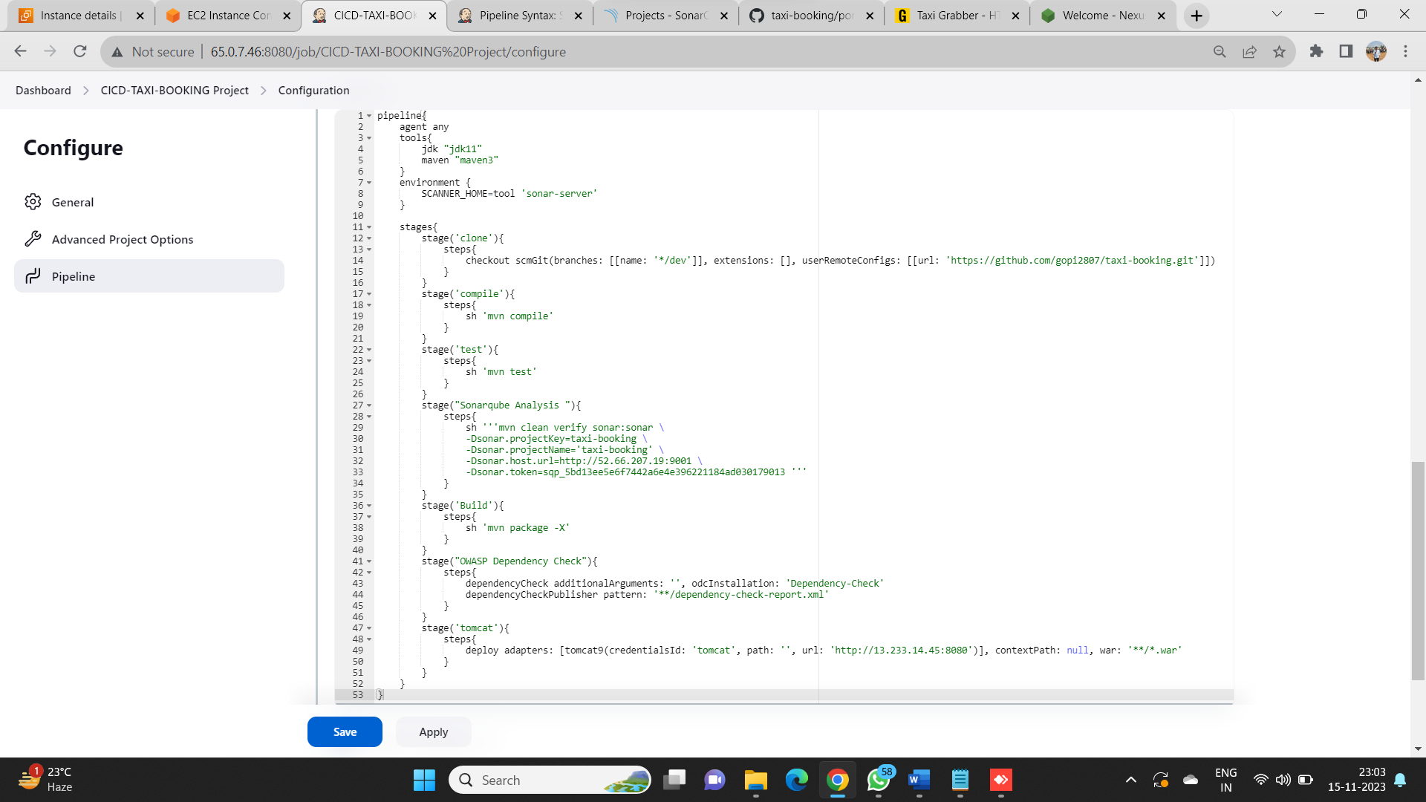**pipeline script:-**

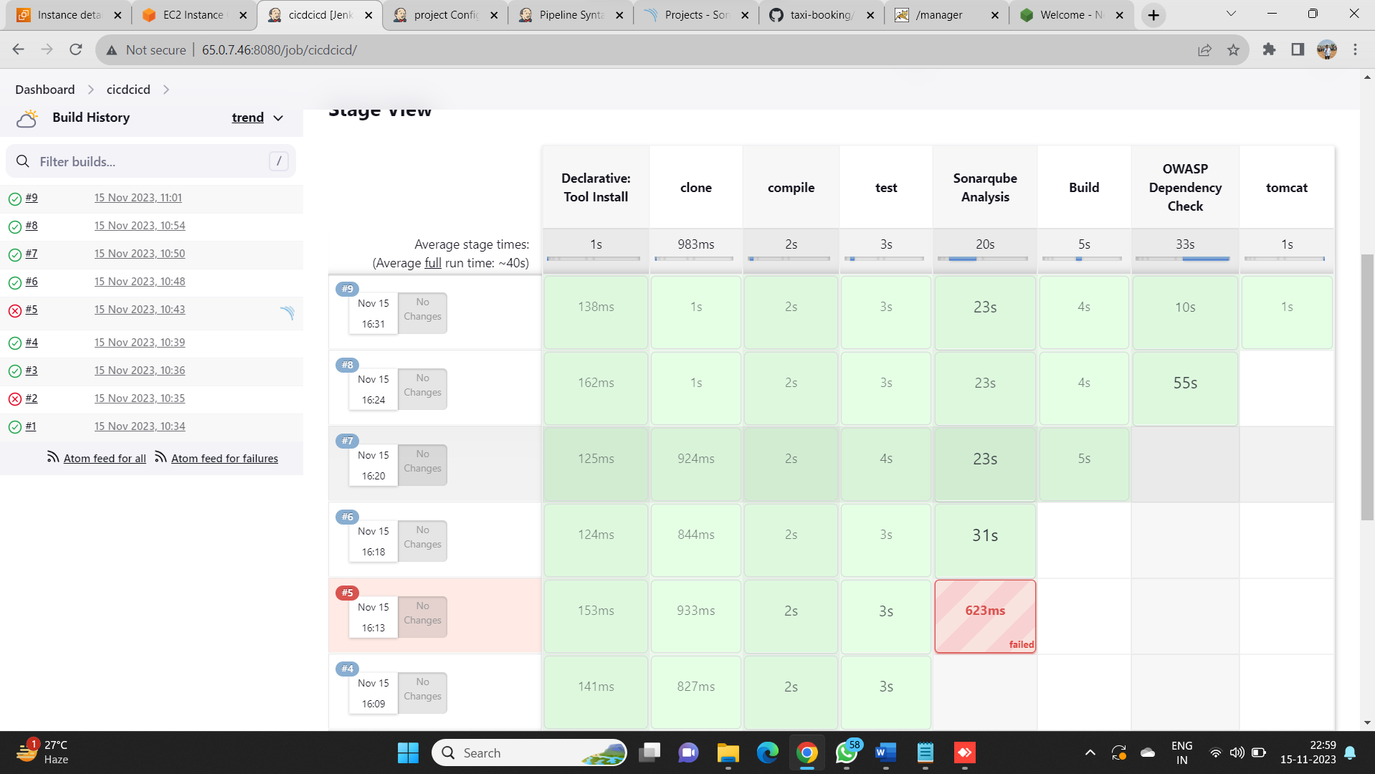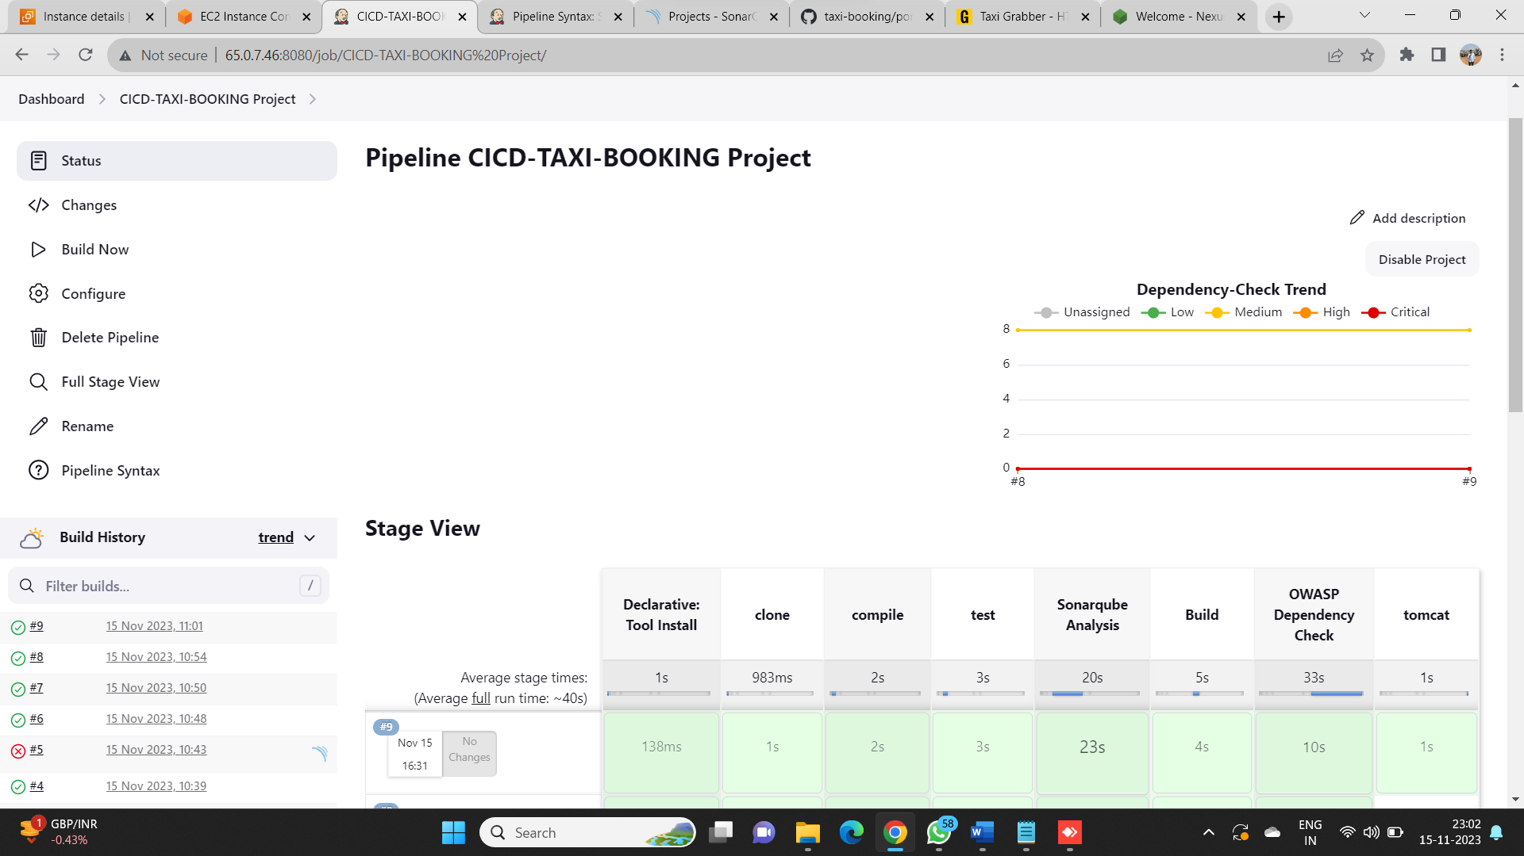**STAGE VIEW:-**

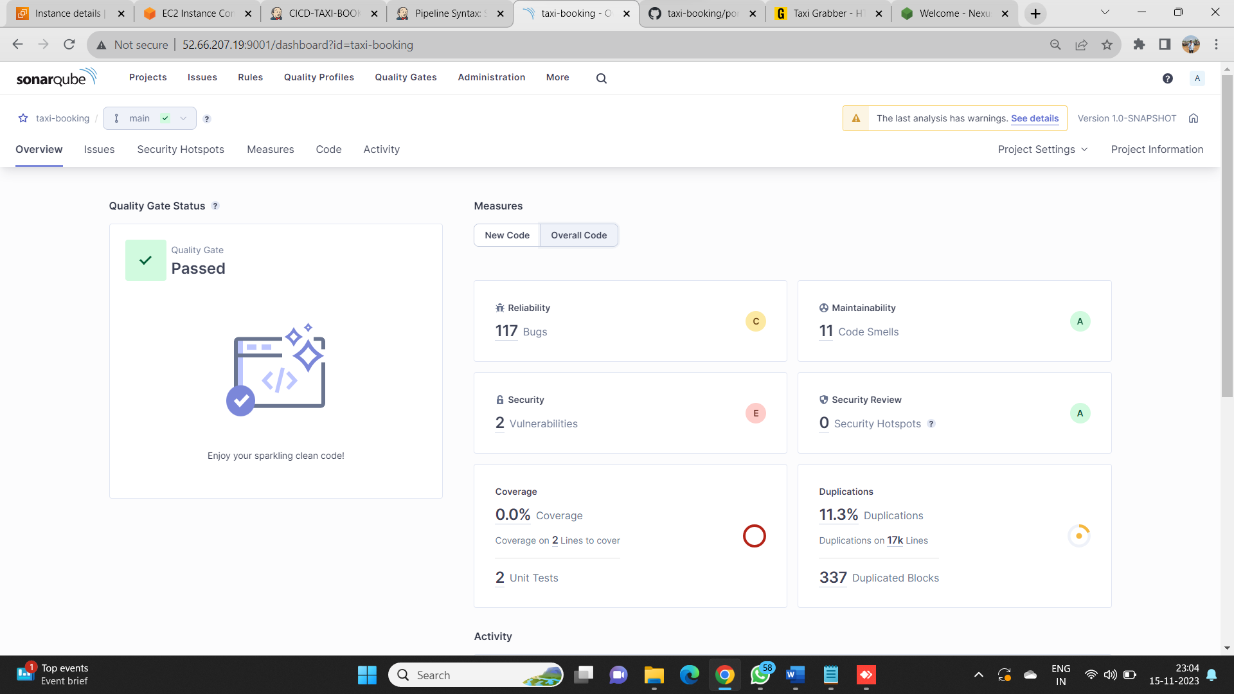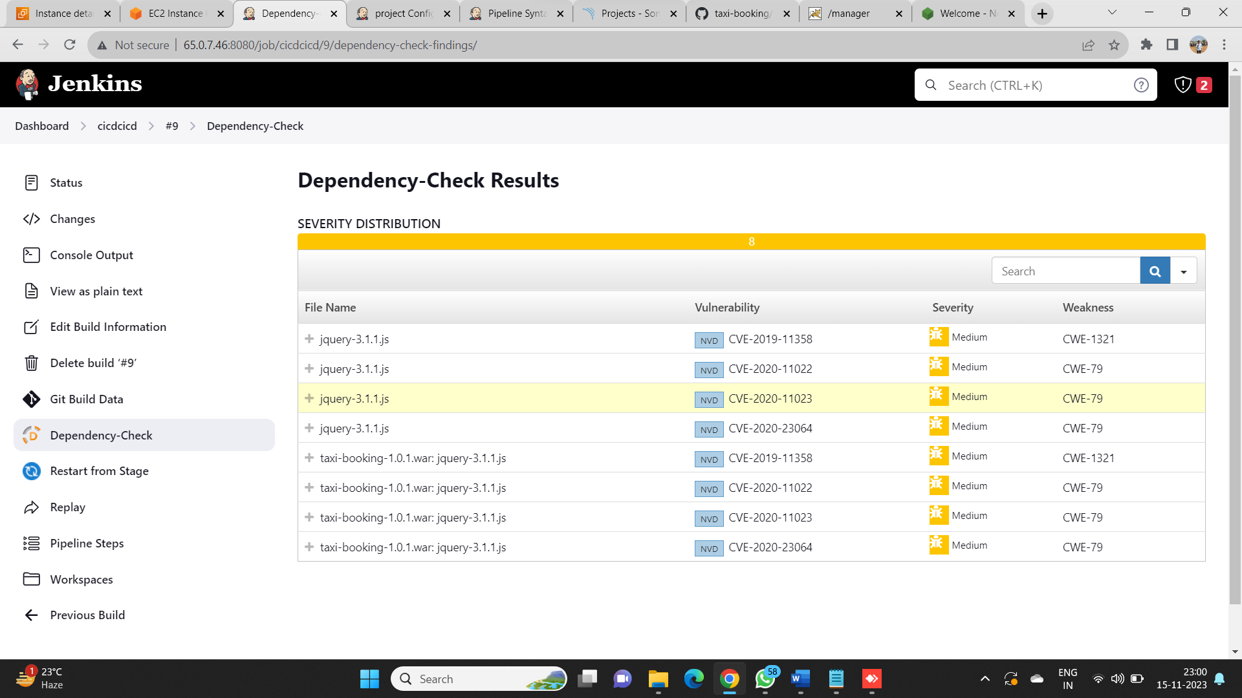**CODE QUALITY TEST IN SONARQUBE:-**

**DEPENDENCY-CHECK:-**

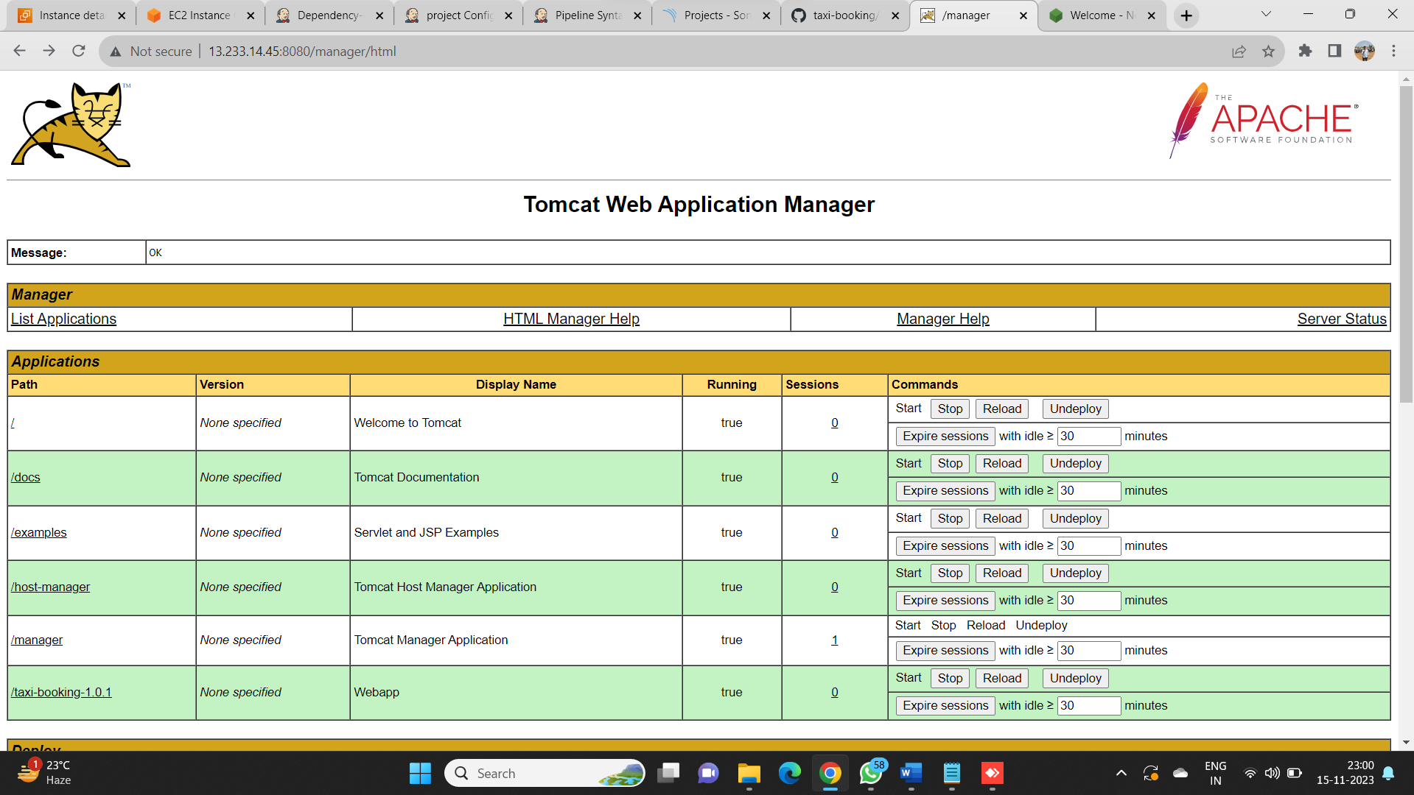**DEPLOY TO TOMCAT:-**

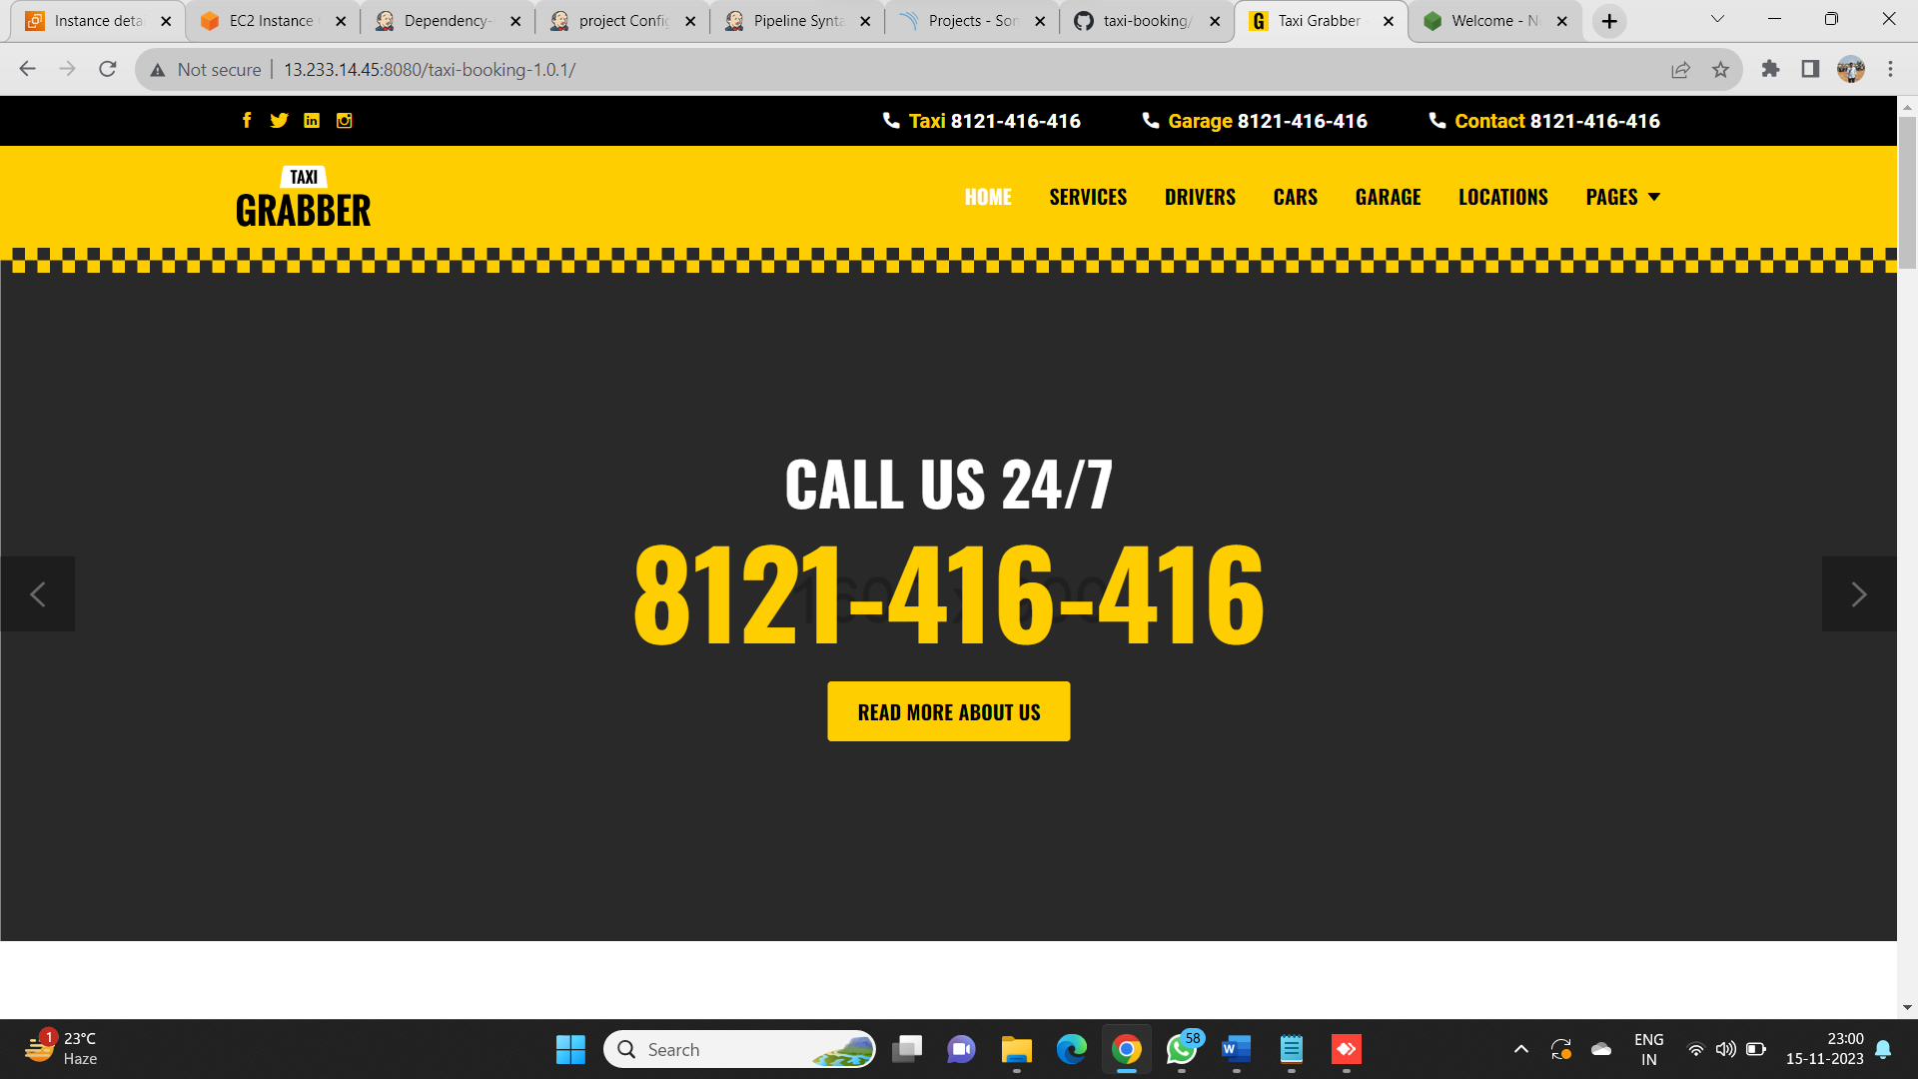**RESULT:-**